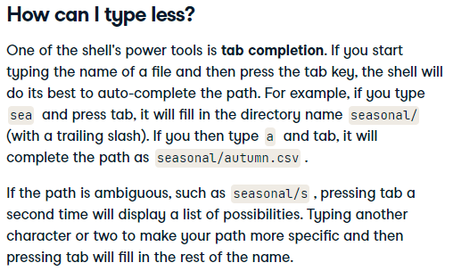

#### 4) Batch processing

#### 5) Creating new tools

